Name: Solutions

Motion, Forces and Energy Test
Total marks: 55

Instructions to students:
Time limit: 55 minutes.
Complete all questions on this paper.
Answer all numerical questions to 3 significant figures. (max. 1 mark penalty)
Use of scientific calculators (supplied by students) and 2014 Physics formula sheet (supplied by teacher) permitted.

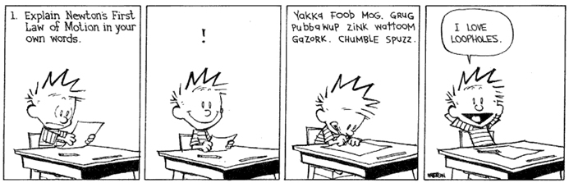

- A rider & bicycle has a combined mass of 45∙6 kg which has a change of speed from 2.85 ms⁻¹ to 4.912 ms⁻¹. Calculate and state the gain or loss in kinetic energy. [3]

K.E. of each (or calculation of change)– 2 marks
Statement of loss or gain – 1 mark

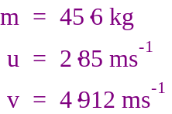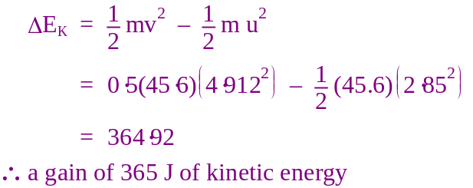

- An electric motor uses 2400 J of electrical energy in 2 minutes.
Calculate the power rating of the motor. [2]

Convert time – 1 mark
Calculate P – 1 mark

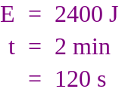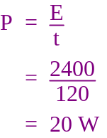

- Wendy has decided to try and an experiment her awesome physics teacher suggested. She takes her bathroom scales into a lift. Before the lift moves the scales show her mass to be 58 kg. What with the scales show her mass to be if the lift accelerates downwards at 2 ms⁻²? [3]
Calculate normal weight – 1 mark
Calculate apparent weight – 1 mark
Calculate apparent mass – 1 mark

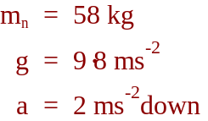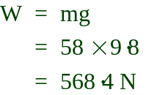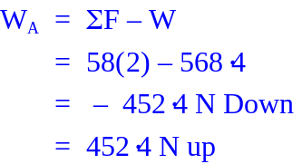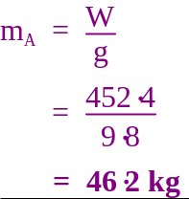

- Draw Free Body Diagrams to represent the following: [3]
  - A 5 kg box is at rest on an inclined plane:

1 mark for each labelled arrow.
-½ if N is not perpendicular or W is not directed downwards
-1 for any force not present (such as a force down the hill labelled ‘applied’ or if friction is directed down the hill instead of up)

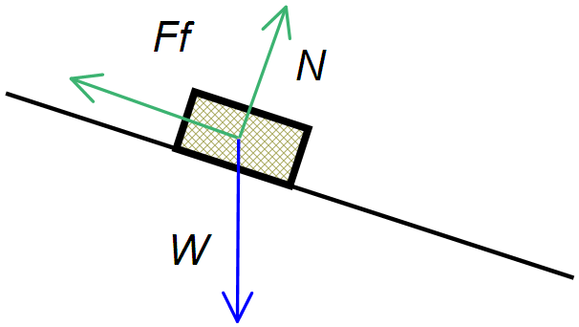

- A car of mass 500 kg travelling west at 25 ms⁻¹ crashes into the rear of a stationary truck with a mass of 6000 kg. The vehicles lock together on impact. [7 marks]

  - What is the total kinetic energy of the system before the collision? [2]
Statement of kinetic energy – 2 marks
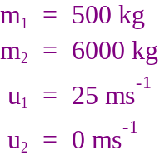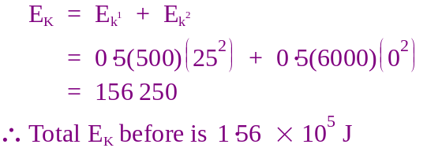

  - What is the velocity of the car and truck immediately after the collision? [2]
Statement of velocity – 2 marks
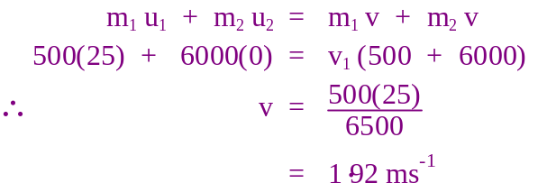

  - What is the total kinetic energy of the system after the collision? [2]
Statement of kinetic energy based upon v in ‘b’ – 2 marks

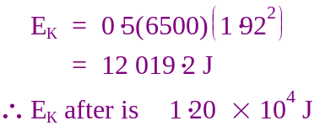

  - Is this an elastic or inelastic collision? Explain [1]

Inelastic, mechanical energy is lost (compare ‘a’ to ‘c’).

- Parents of young children buy a swing set for their children. The swing has two ropes connected to the 2·4 kg seat and rests 0·85 m above the ground. [11 marks]

  - Draw a free body diagram showing all forces when the swing is at rest. [2]
FBD with 2 tension forces and weight – 2 marks
Tension only – 1 mark
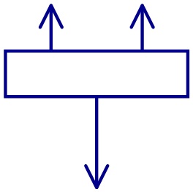
  - What is the tension in the rope when the swing is empty? [2]
Statement of tension – 2 marks
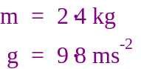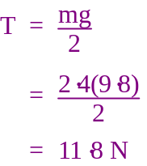

An older child whose mass is 35 kg sits on the swing. The mass of the child is too great for the swing and the rope breaks.

  - What was the potential energy of the swing and child when the rope broke? [2]
Statement of P.E. – 2 marks

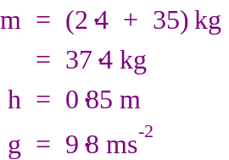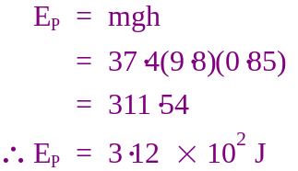

  - How long does it take the child to fall to the ground? [2]
Statement of time – 2 marks
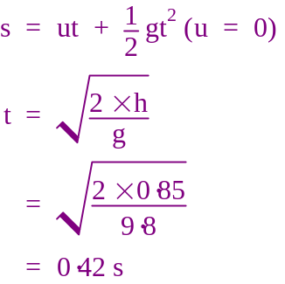

  - ‘Softfall’ is a rubber substance used on the ground of playgrounds. Explain using physics principles why a child is less likely to be injured if they fall onto ‘Softfall’ compared to concrete: [3]

It takes an impulse equal to the childs momentum when the child hits the ground to bring the momentum to zero. – 1 mark
Softfall increases the time taken to decelerate to rest. – 1 mark
Since t increases, F decreases, reducing the likelihood of injury. – 1 mark
- A model rocket with a mass of 600 g exerts takes off vertically with a thrust of 80 N. It takes 0∙45 s for all its fuel to burn. [8 marks]

  - Neglecting air resistance, draw a diagram showing all forces on the rocket in flight and calculate the net force on the rocket: [2]
Show appropriate vector length and direction – 1 mark
Correctly calculates net force – 1 mark

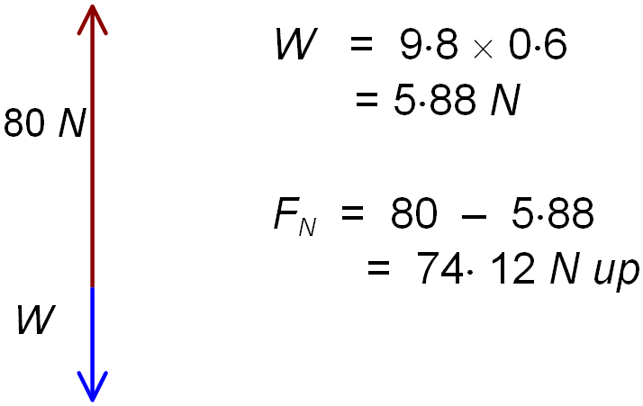

  - What is the net acceleration of the rocket? [2]
Statement of acceleration – 2 marks

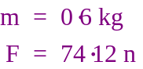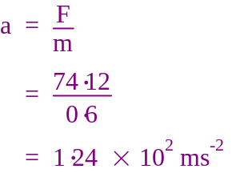

  - What is the height of the rocket when the rocket fuel runs out? [2]
Statement of height – 2 marks

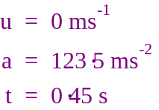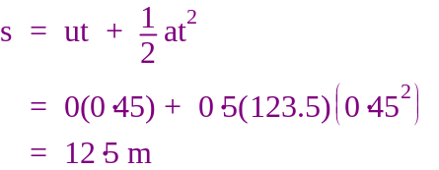

  - What work is done on the rocket in the 0.45 s? [2]
Statement of W (W = Fs) – 2 marks

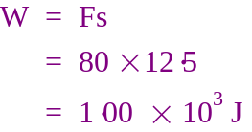

- Declan is practising throwing balls. He throws a 150 g rubber ball with a velocity of 4∙2 ms⁻¹ at a basketball sitting on the ground. The basketball has a mass of 620 g and rolls away with a velocity of 1∙45 ms⁻¹. What is the velocity of the rubber ball after hitting the basketball? [4]
Sets up conservation of momentum equation correctly - 1
Enters data correctly - 1
Statement of velocity – 2 marks
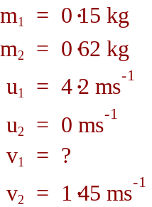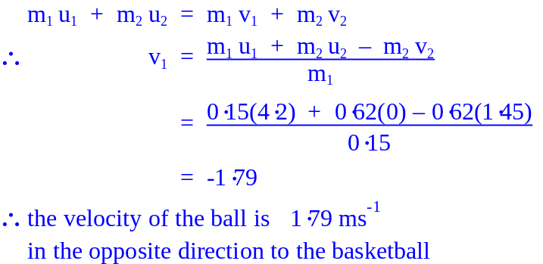

- A boy riding a skateboard on a footpath has a mass of 35∙8 kg with a velocity of 14∙45 ms⁻¹ when he crosses over to a section of grass. The grass provides a retarding force of 50 N for 2∙5 s against his motion, before he returns to the footpath. What is the velocity of the boy when he returns to the footpath? [3]
Statement of acceleration – 1 mark
Statement of final velocity – 2 marks
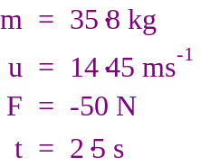 | 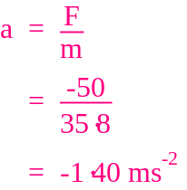 | 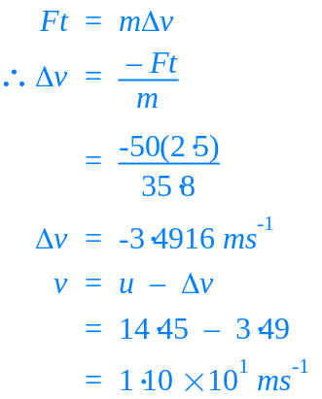
 | 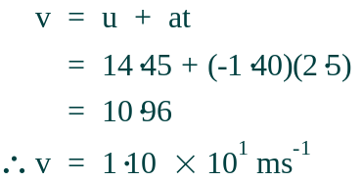

- In Australia drivers and passengers in cars are required to wear seatbelts. By naming and using physics principals explain why not wearing a seatbelt during a collision is unsafe. [3]

Newton’s First law – an object will continue in motion unless acted upon by an unbalanced force.
In a head on collision a large force will decelerate the car quickly.
If no force is present to decelerate the passenger will continue forward and collide with the dashboard or windscreen.
Seatbelt provides this force.

- On a recent visit to Adventure World John decides to go down the ‘Giant” water slide. He and his rubber matt have a combined mass of 78∙9 kg. John is at rest at point A and allows gravity to accelerate him down the slide. [8 marks]

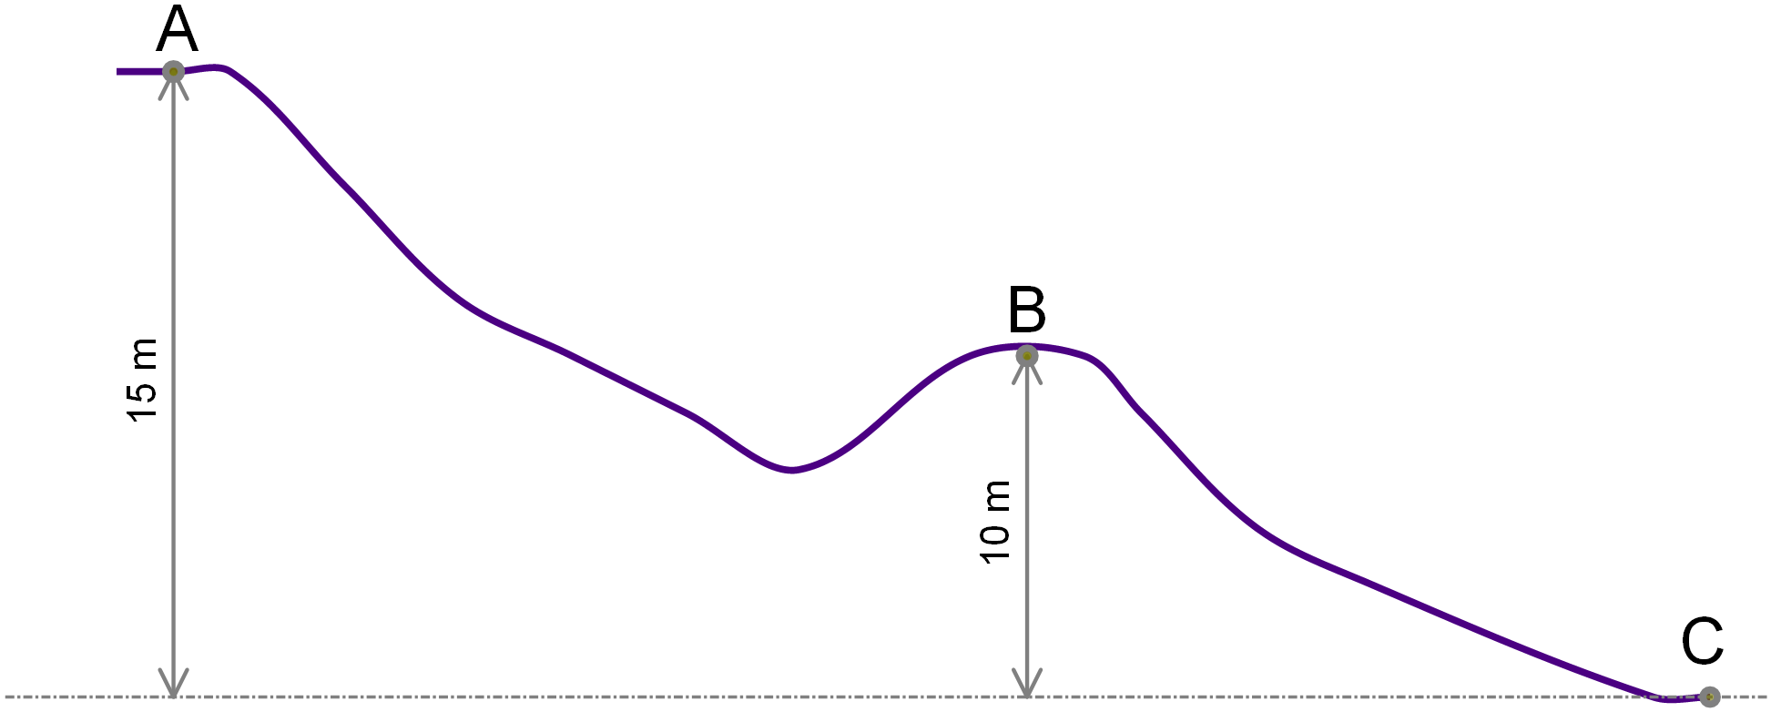

  - Calculate the velocity of John when he reaches point B assuming no loss of energy to friction: [3]
Calculate PE at A – 1 mark
KE(B) = PE(A) – PE(B) – 1 mark
Statement of v at B
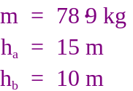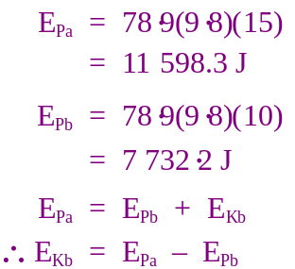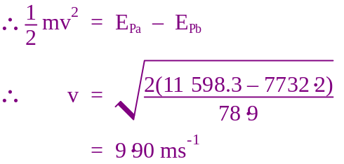

  - As John passes point B he panics and tries to use his feet to slow himself down so that he loses 5% of his mechanical energy between point B and C. What is John’s velocity at point C? [2]
Calculate final total mechanical energy (- 5%) – 1 mark
Statement of v – 1 mark
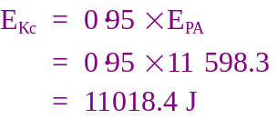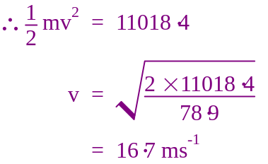

  - After several complaints about safety it was decided to add a ‘slow down zone’ at the end of the slide. What retardation force must this zone provide so that of John comes to rest in no less that 1∙6 s? (if you were unable to calculate a velocity above use v = 20 ms⁻¹) [3]
Statement of F – 3 marks
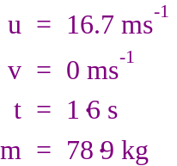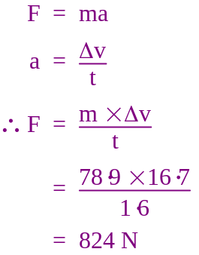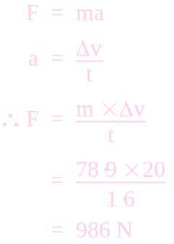

END OF TEST

